# A000-PAC-POLY-Kohala Hawai’i-Adze-Tri Lateral Marquesan-Basalt-800 CE

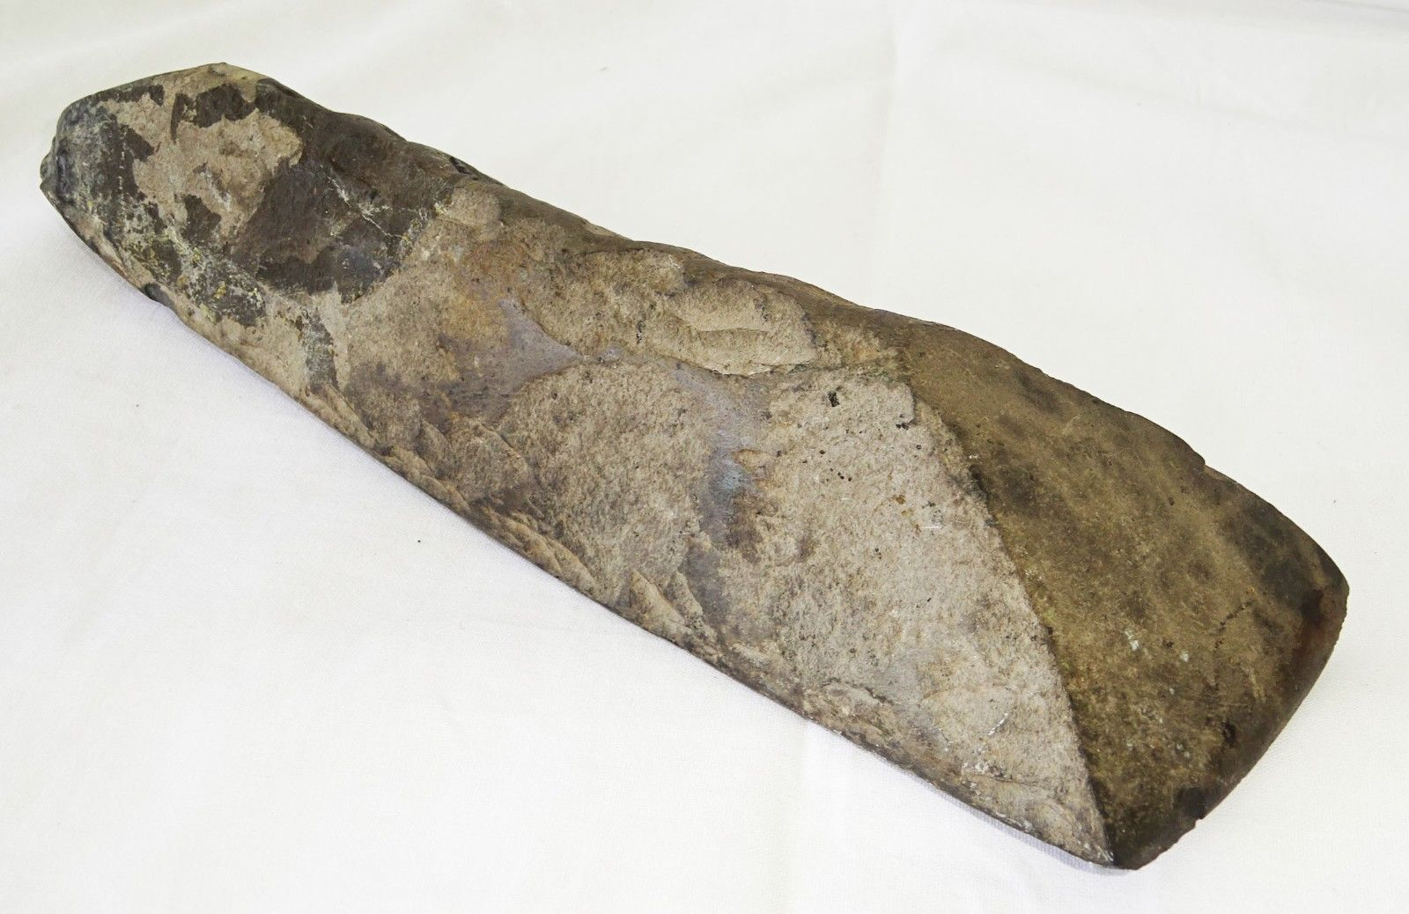

Fig. 1. **PAC-POLY-Kohala Hawai’i-Adze-Tri Lateral Marquesan-Basalt-800 CE** Case no.: Oceania

Case No.: 13

Accession Number:

Formal Label: **PAC-POLY-Kohala Hawai’i-Adze-Tri Lateral Marquesan-Basalt-800 CE**.

**Display Description:**

Marquesan Basalt Trilateral Adze. Extremely rare as this is one of the few basalt adzes that have the trilateral (three sided) style found in Hawaii that demonstrate the tradition of Marquesan adze style in the Hawaiian Islands. This example, found in Kohala district on the Island of Hawai’i, suggests a Marquesan presence on the island at an early time, c 800 CE, further supporting the argument that Hawai’i was settled originally by Marquesans. The trilateral adze is a Marquesas design. In the period 300 to 600 CE Polynesians from the Marquesas Islands were the first to reach the Hawaiian Islands.

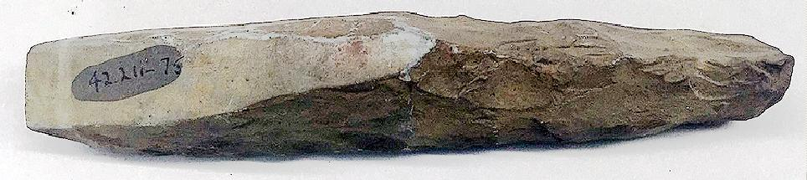

Fig. 2 Marquesan trilateral basalt adze, Brooklyn Museum 3 1/8 x 1 5/16 x 1 3/4 in. (8 x 3.3. x 4.5 cm), A. Augustus Healy Fund, 42.211-75. (Photo: Brooklyn Museum, CUR.42.211.75.jpg).

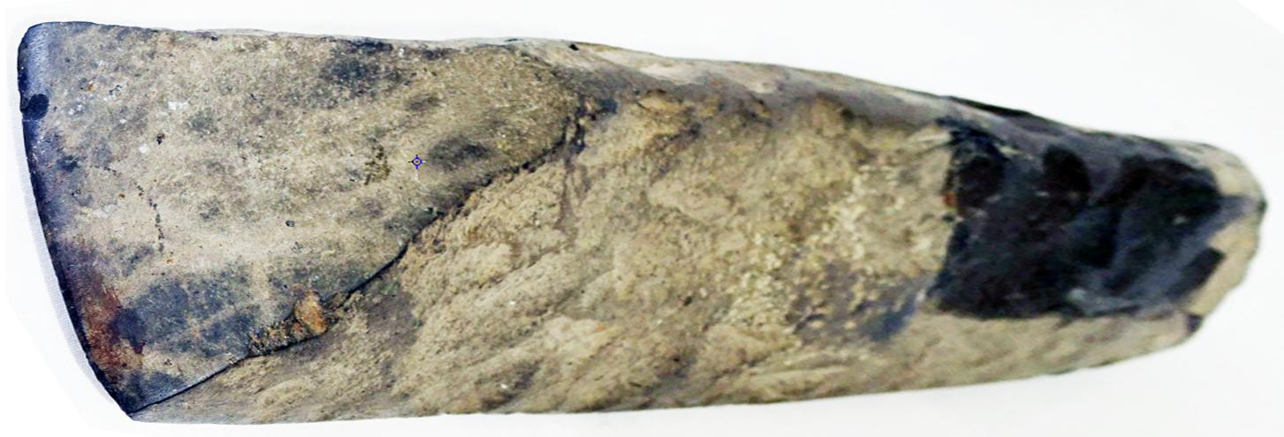

Marquesas, Nuku Hiva, trilateral basalt adze, from an old collection with accession number painted over (?).10 in x 2.75 in.

EX collector in Honolulu, then André Harnisch, 2016, Hawai’i, US $1,289.00. Photo: André Harnisch.

**LC Classification:**

**Date or Time Horizon:**

**Geographical Area:**

**Map:**

**GPS coordinates:**

**Cultural Affiliation:**

**Media:**

**Dimensions:**

**Weight:**

**Condition:**

**Provenance:**

**Discussion:**

**References:**